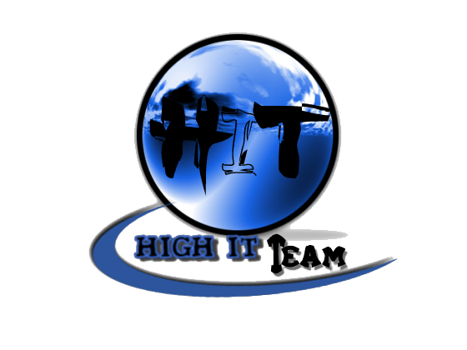
Team Assignment 04
HIT
3/2/2012

Software Measurement and Analysis

Team members: | Members ID
Giang Thị Ha Thanh | T097828
Trần Dũng Đạt | T095716
Nguyễn Vũ Trọng Giang | T096656
Huỳnh Chấn Huy | T096498
Tạ Quang Hiệp | T090363
Nguyễn Trần Hồng Phúc | T095014

A paper (≤ 2 pages) briefly describing how a software development methodology impacts the team’s GQM definitions.
In this dissertation, I have described the characteristics of some traditional and agile methodologies that are widely used in software development. I have also discussed the difference between the two opposing methodologies and provided the challenges associated.

 | Traditional | Agile
Requirement | - Assume that requirements can be known at the start of the project  - Requirements difficult to define up front.  - Users tend to define as many requirements that they can think of. | Assume that requirements will emerge
Requirement |  | Requirements are documented as “user stories” (a backlog of product features)
Requirement |  | Lack of long range requirements means minimal long range planning
Requirement |  | Emerging requirements requires management to delegate decision-making authority to the Scrum team.
Customer Meeting | Product Owner/User involvement with development team is minimal after requirements are approved | - Product Owner/User works closely with development team on a daily basis  - Guaranteed to meet customer needs (Product Owner determines the user stories to implement each sprint)
Upfront Planning & Schedule | Schedule, budget, architecture and design for entire project can be created “up front” given requirements | Schedule, budget, architecture and design for project evolve as requirements emerge
Upfront Planning & Schedule |  | Pre- and post-sprint planning & acceptance activities
Upfront Planning & Schedule |  | Short (<30 minutes) daily standup meetings to communicate status & problems
Change and Rework | Change managed formally. Rework is bad | Change is managed informally. Rework (refactoring) is good
Documentation | Lots of documentation  Can produce excessive documentation | Minimal documentation. Requirements defined as user stories
Team and Developers | Supports technically weak staff | Teams are self-organizing  Development team is trusted  Requires more senior developers  Some workers are not comfortable with the responsibility Scrum enables
Process | An over reliance on processes (that may not be working well or followed)
Release | Few visible signs of progress until the end | Product built so you always have a working system and can “release” at any time.
Release | Few visible signs of progress until the end | Each sprint produces a potentially shippable product
Cycles | Stable product definition  Limitation. | Implementation occurs in short ‘sprints’.  Numerous cycles
Risk | Unknown Risks, Major Impact | Well understood risk, minor impact

Another argument between agile and heavyweight methodologies is the measurement of project success. A predictive heavyweight project considers handing a project that is on-time and on-cost to be a success [17].However agilists measures project success by questioning if the customer got software that is more valuable to them than the cost put into it.
Whenever I need metrics or reporting information about a piece of software or a software project, I find it highly useful to follow the GQM method in a pragmatic manner, to clarify what information exactly is required, how it can be obtained, and what needs to be considered when interpreting the data
Goal | Question | Measure | Metric | Traditional | Agile
Requirement | What was the number of change requirements in project | N: Number of change | N | Change rarely happen  N: small | Change usually happen  N: big
Requirement | What was the effect when the requirement changed? | LOC: line of code had changed when requirement change  N: Number of change  D:line of code average for a change | D = LOC/N | Requirement change make huge effect to project  D: big | Requirement change make small effect to project  D: small
Customer Meeting | How many times does team meet customer each phase? | N: Number  P: Number of phase  D: Number of meeting | D = N/P | Rarely meet customer  D: small | Usually meet customer  D: big
Upfront Planning & Schedule | What was the number of change in: Schedule, budget, architecture and design for entire project | N: Number of change | N | Change rarely happen  N: small | Change usually happen  N: big
Upfront Planning & Schedule | How long will the project take when requirement change? | D: day | D | Huge effect to the schedule  D: big | Small effect to the schedule  D: small
Change and Rework | How is the change management process? | Numbers of change request approved (measured by change request): X  - Numbers of change request (measured by change request): D  - Rate of change request approved and change request (measured by %): R | 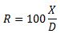 | Every change must be highly consider  R: small | Change happen usually and easy accept  R: big
Documentation | What was the number of document in project? | N: number | N | Many documents  N: big | Less document  N: small
Release | What was the number of product release in the project? | N: number | N | Release at the end of project  N = 1 | Shippable product  N: big
Cycles | How many cycles were used in the entire project? | N: number | N | Only 1 cycle  N =1 | There have one cycle after each release  N: big
Risk | What was the ability to predict risk? | N: number of risk which team project correct predict  T: total of risk which team project predict  D: Rate of risk which predicted | D = N/T | Hard to predict  D: small | Risk can predictable  D: big
Risk | What was the effect when risk occur (problem)? | LOC: line of code had changed when risk occur  N: Number of risk  D: line of code average must change for a risk | D = LOC/N | Risk make a huge effect to all project  D: big | There are more than one cycle so when risk happen, it will be fix after that  D: small

